**PRACTICAL NO:-5**

**a. Create Web Form to demonstrate use of Website Navigation controls.**

**1)TreeView controller:-**

First we create a new sitemap file extension as .sitemap

Add below content to that file:-

**CODE:-**

<?xml version="1.0" encoding="utf-8" ?>

<siteMap xmlns="http://schemas.microsoft.com/AspNet/SiteMap-File-1.0" >

<siteMapNode url="" title="" description="">

<siteMapNode url="root.aspx" title="home" description="" >

<siteMapNode url="node1.html" title="About" description="" />

<siteMapNode url="node2.html" title="Contact us" description="" />

</siteMapNode>

<siteMapNode url="root2.aspx" title="feedback" description="" >

<siteMapNode url="r2ch1.html" title="technical issue" description="" />

</siteMapNode>

</siteMapNode>

</siteMap>

Then added the data source from here:-

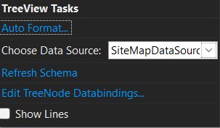

And then choose sitemap file here.

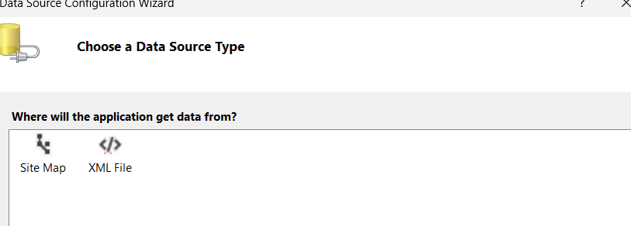

**OUTPUT:-**

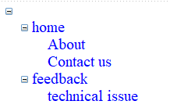

On click on technical issue we are redirecting to that website.

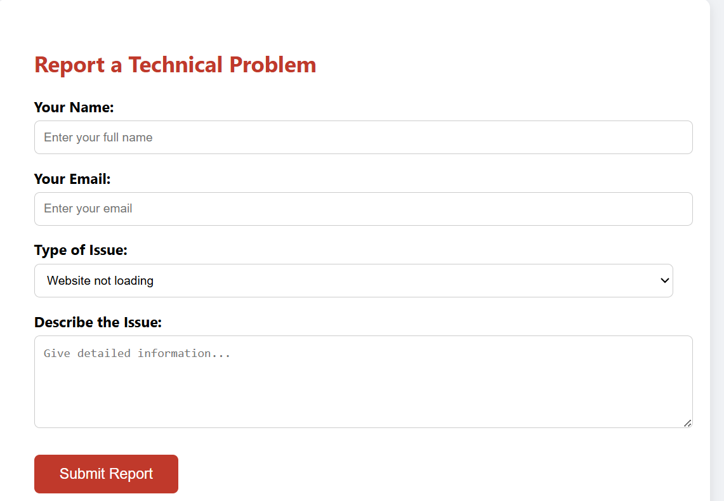

**2)Menu:-**

First we add the items in Menu

Choosing edit menu item option.

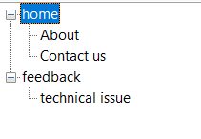

Then set heirachy.

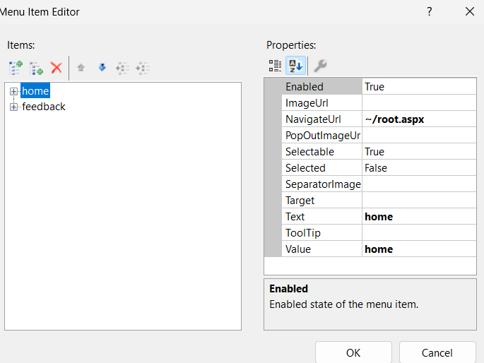

Then assign text and the navigate url path for it.

**OUTPUT:-**

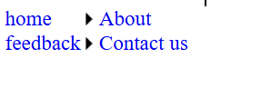

**C)sitemappath:-**

First it is required to choose a **empty page** ,not web forms. Otherwise you have to configured it much manually.

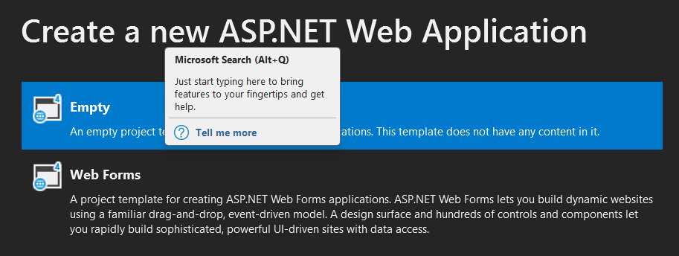

Here we directly drag and drop the **sitemappath** it will directly takes current node and hierarchy from .sitemap file .if you want to use current node as well as active node then have to set following property :-



The sitemap file for this is as follow:-

<?xml version="1.0" encoding="utf-8" ?>

<siteMap xmlns="http://schemas.microsoft.com/AspNet/SiteMap-File-1.0" >

<siteMapNode url="" title="" description="">

<siteMapNode url="root.aspx" title="home" description="" >

<siteMapNode url="node1.html" title="About" description="" />

<siteMapNode url="node2.html" title="Contact us" description="" />

</siteMapNode>

<siteMapNode url="root2.aspx" title="feedback" description="" >

<siteMapNode url="r2ch1.html" title="technical issue" description="" />

</siteMapNode>

</siteMapNode>

</siteMap>

**OUTPUT:-**

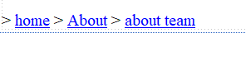

When you clicked on the node you can traverse through this hierarchy.:-

As follow:-

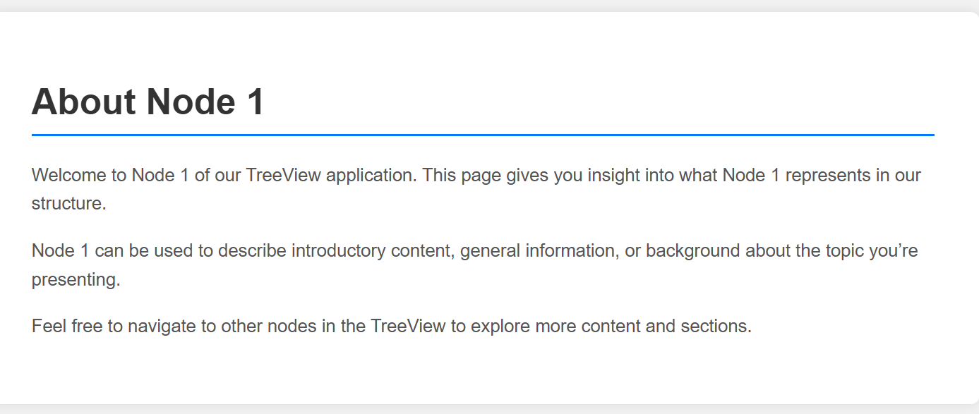

**c. Create a web application to demonstrate various states of ASP.NET Pages.**

**ViewState:-**

The state manage for one user.

**CODE:-**

using System;

using System.Collections.Generic;

using System.Linq;

using System.Web;

using System.Web.UI;

using System.Web.UI.WebControls;

namespace practical_some_first

{

public partial class viewstate : System.Web.UI.Page

{

protected void Page_Load(object sender, EventArgs e)

{

}

protected void TextBox1_TextChanged(object sender, EventArgs e)

{

ViewState["User"] = TextBox1.Text;

Label1.Text = "Hello " + ViewState["User"].ToString();

}

}

}

**OUTPUT:-**

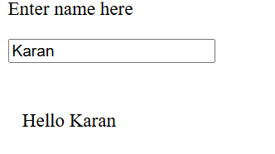

**Session:-**

Session is manage for the single user.

**CODE:-**

using System;

using System.Collections.Generic;

using System.Linq;

using System.Web;

using System.Web.UI;

using System.Web.UI.WebControls;

namespace practical_some_first

{

public partial class viewstate : System.Web.UI.Page

{

protected void Page_Load(object sender, EventArgs e)

{

if (Session["user"] != null)

{

Label2.Visible = false;

TextBox1.Visible = false;

Label1.Text = "Hello " + Session["User"].ToString();

Button1.Visible = false;

}

}

protected void TextBox1_TextChanged(object sender, EventArgs e)

{

}

protected void Button1_Click(object sender, EventArgs e)

{

Session["User"] = TextBox1.Text;

Label1.Text = "Hello " + Session["User"].ToString();

}

}

}

**OUTPUT:-**

When I first try to access the website it was ask me for my name.:-

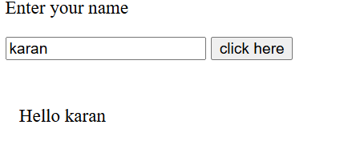

Then I reload page or open tab it directly shows me output:-



But when try as another use it again ask for name.

**Application:-**

Application remain for all the user that are using it:-

**CODE:-**

using System;

using System.Collections.Generic;

using System.Linq;

using System.Web;

using System.Web.UI;

using System.Web.UI.WebControls;

namespace practical_some_first

{

public partial class viewstate : System.Web.UI.Page

{

protected void Page_Load(object sender, EventArgs e)

{

if (Application["user"] != null)

{

Label2.Visible = false;

TextBox1.Visible = false;

Label1.Text = "Hello " + Application["User"].ToString();

Button1.Visible = false;

}

}

protected void TextBox1_TextChanged(object sender, EventArgs e)

{

}

protected void Button1_Click(object sender, EventArgs e)

{

Application["User"] = TextBox1.Text;

Label1.Text = "Hello " + Application["User"].ToString();

}

}

}

**OUTPUT:-**

When I first try to access the website it was ask me for my name.:-



Then I reload page or open tab it directly shows me output. Also I enter as another user in Incognito mode it still shows me username.



**b. Create a web application to demonstrate use of Master Page and content page.**

We first create a master page .Master extension,

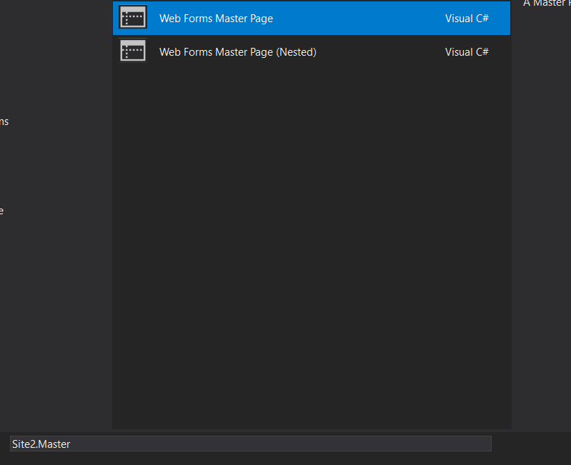

Then adding content to it without adding content the content placeholder in master page.

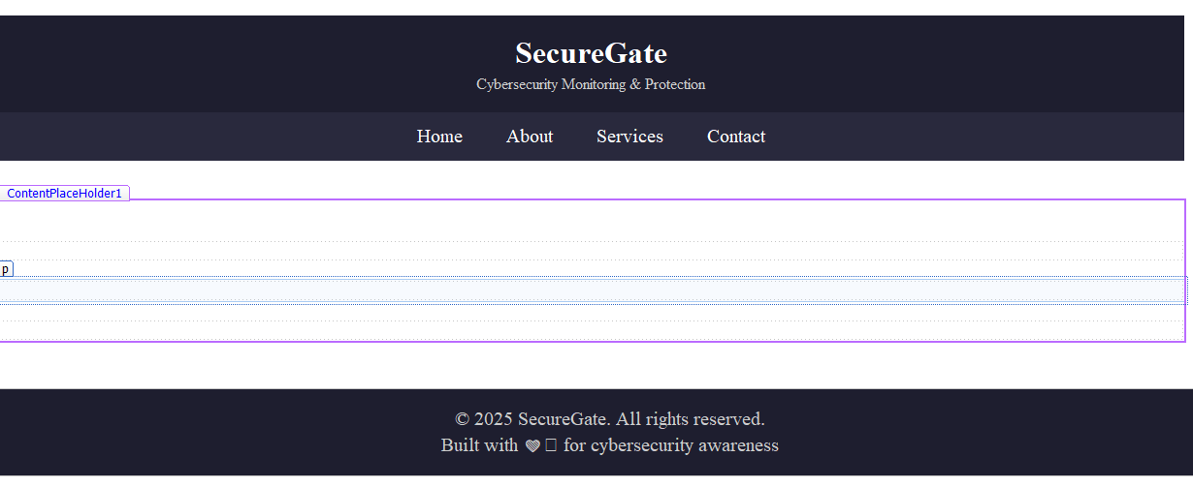

Now adding web form with master page:-



And choosing the master page for it:-

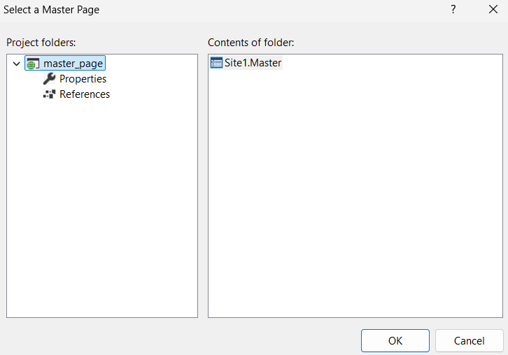

Now adding content to the slave pages into placeholder.:-

Adding content the slave 1:-

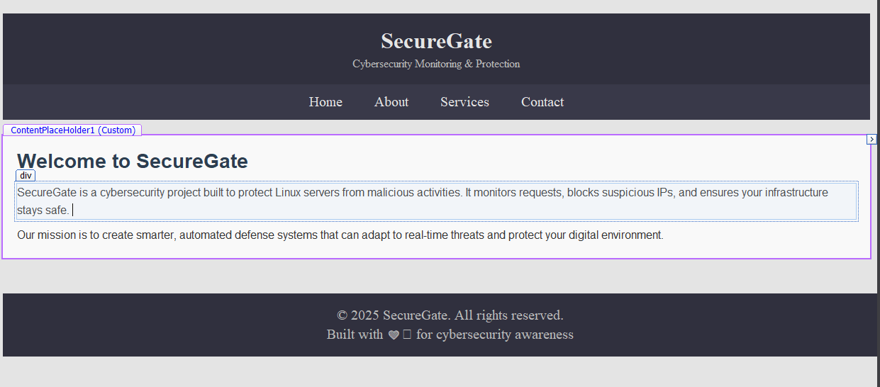

Adding content to the slave 2:-

